Thermal overstress aging with DC gate voltage bias
The Matlab file “20080429T135531.mat” contains data from a thermal overstress aging experiments using a DC bias in the gate voltage. The experiment controls the package temperature within a range outside the rated temperature of the device with the objective of accelerating the aging of the device. Several parameters were monitored like collector current, collector voltage, gate voltage and package temperature.
The configuration of the device consists on connecting the emitter to the ground of the power supply and the collector with a resistor in series to the positive lead of the power supply. The gate was driven by an independent power supply which ground was also connected to the emitter.
The data collection on this experiment was done with standard data acquisition equipment from National Instruments and referred to in our IEEE Autotestcon paper (attached here) as steady-state measurement. What this mean is that the measurements were slow and some of the detail of the transients response after switching is lost. From this data though, it can be observed that the shape of the collector current after switch-OFF changes as the device ages. This current tail is considered as a leading indicator of failure (failure precursor) for the development of prognostics algorithms.

Experiments settings
- Gate Voltage (Vg): 10V DC
- Low Temperature Threshold: 268ºC
- High Temperature Threshold: 270ºC
- Max Temperature: 305ºC (Thermal runaway setting)

Experiments comments
- Experiment lasted approx. 4 hrs.
- Experiments stopped after latch-up and thermal runaway
- Brought up package temperature incrementally (220ºC, 240ºC, 270ºC)
- Device part number: IRF-G4BC30KD

Representative plots

Temperature:
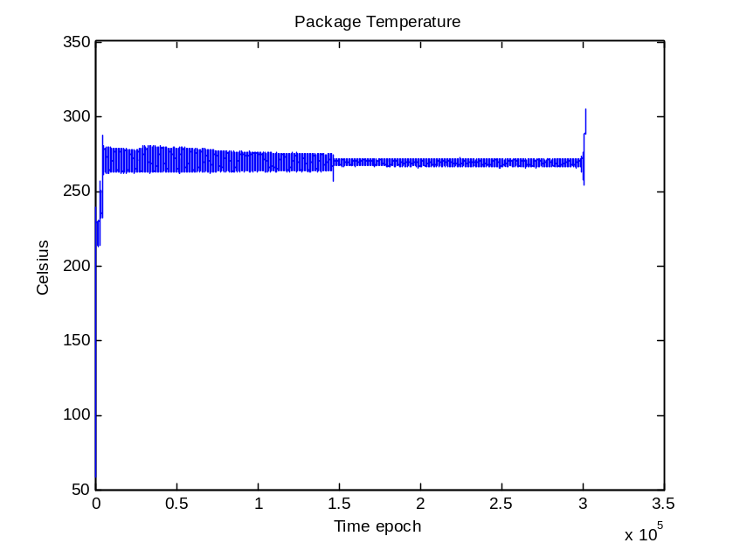
Figure 1: Package temperature measurement throughout aging time period.

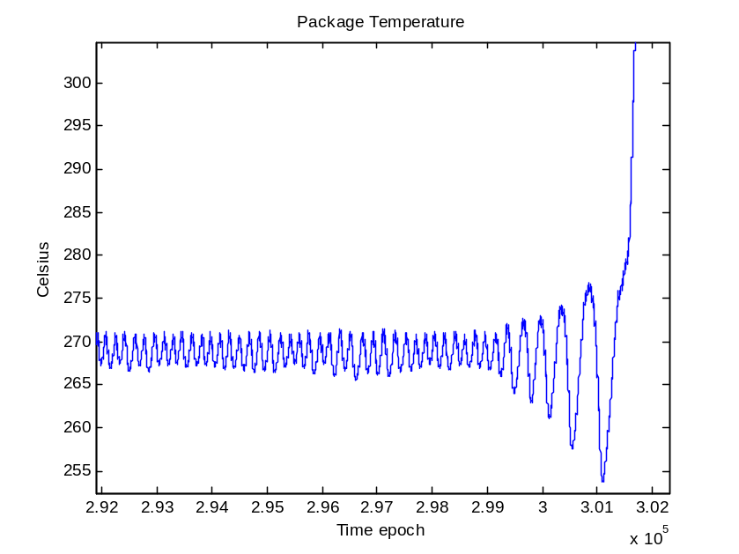
Figure 2: Package temperature measurements at the end of aging (thermal runaway).

Collector-Emitter Current:
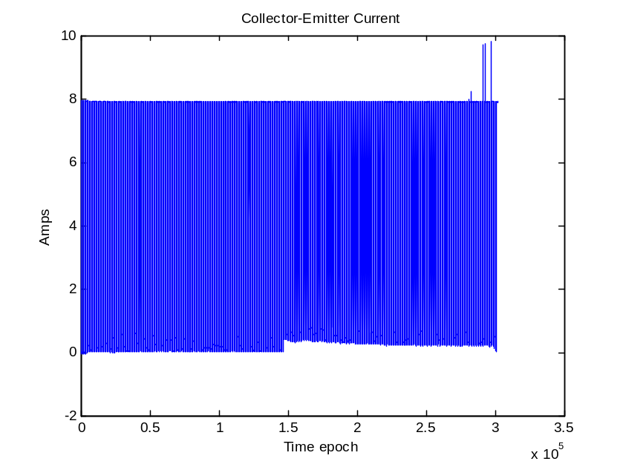
Figure 3: Collector current measurement throughout aging time period.
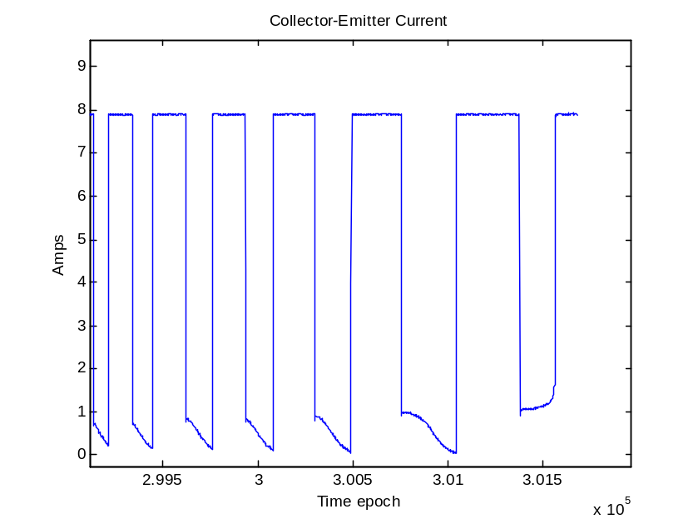
Figure 4: Collector current measurements at the end of aging (thermal runaway).

